Experiment 10: Student Information System Using Cloud Computing
Aim
To create a simple cloud-based software application using Zoho Creator to store and display student information, including personal details, grades, attendance reports, progress reports, and semester mark sheets, demonstrating SaaS.
Algorithm
- Open Zoho Creator and sign in.
- Create a new application named Student Information System.
- Create a form named Student Information.
- Add fields for student name, registration number, address, phone, and age.
- Add fields for courses and grades.
- Create an Attendance Report form.
- Create a Progress Report form.
- Create a Semester Mark Sheet form and save the application.
- Enter student details, view the records, and verify the application.
Implementation
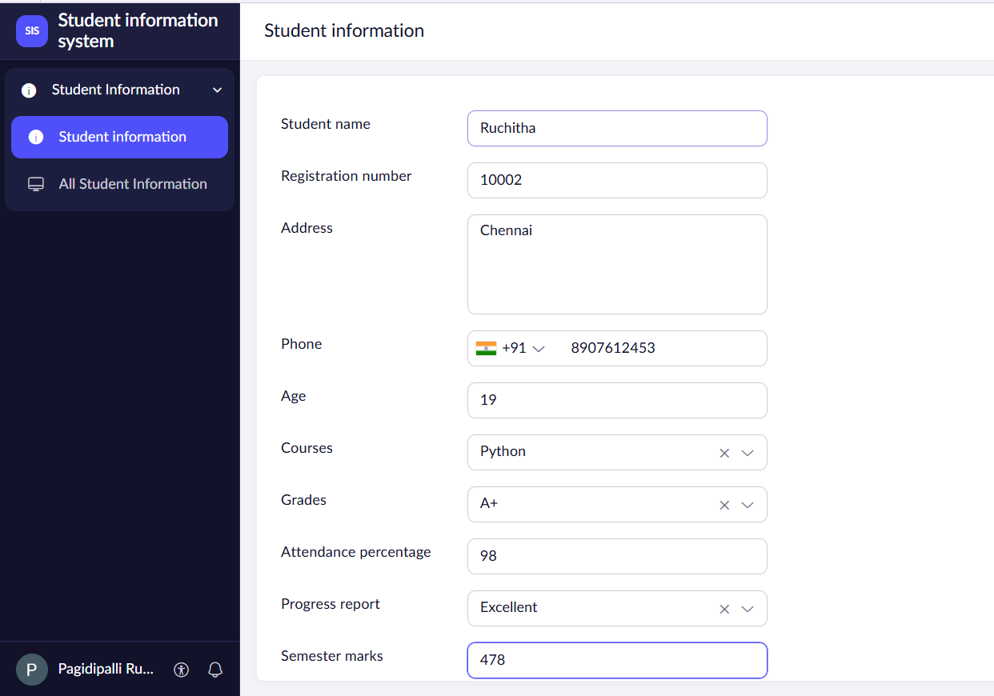
Input

Output
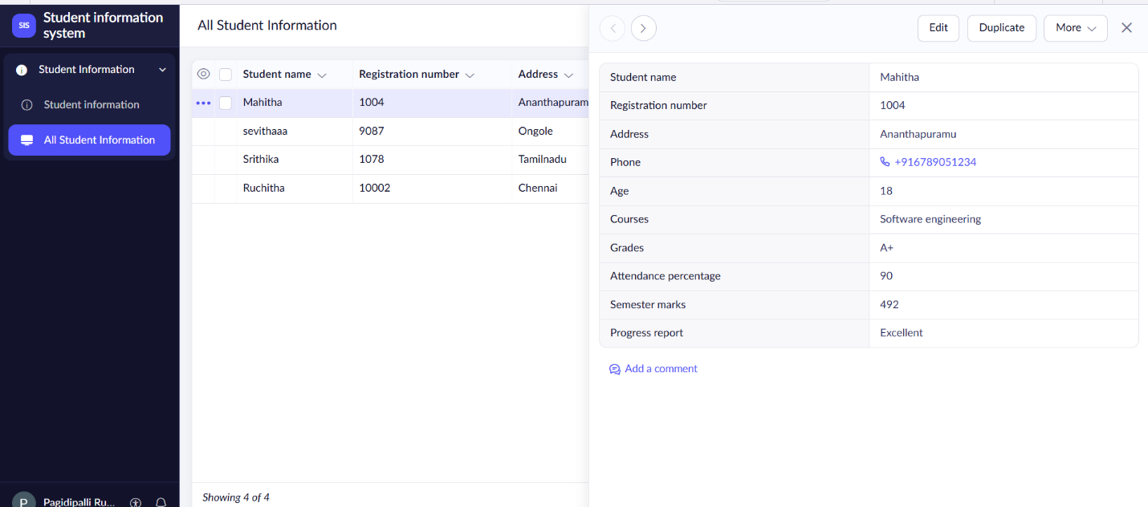

Result
Thus, a cloud-based Student Information System was created successfully using Zoho Creator to store and display student details, grades, attendance, progress reports, and semester mark sheets, demonstrating SaaS.

